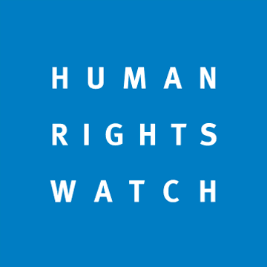

A life of danger for people with disabilities and older people in South Sudan

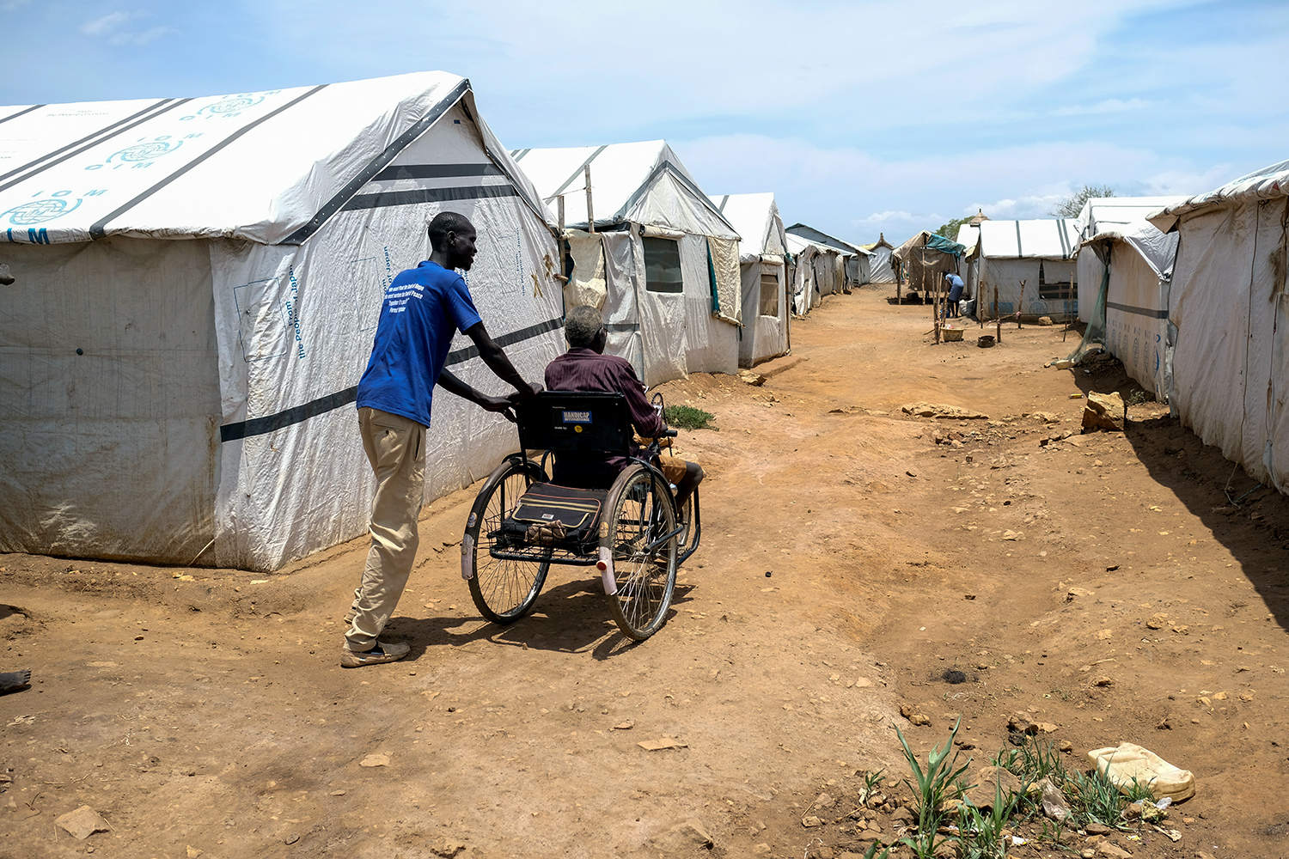
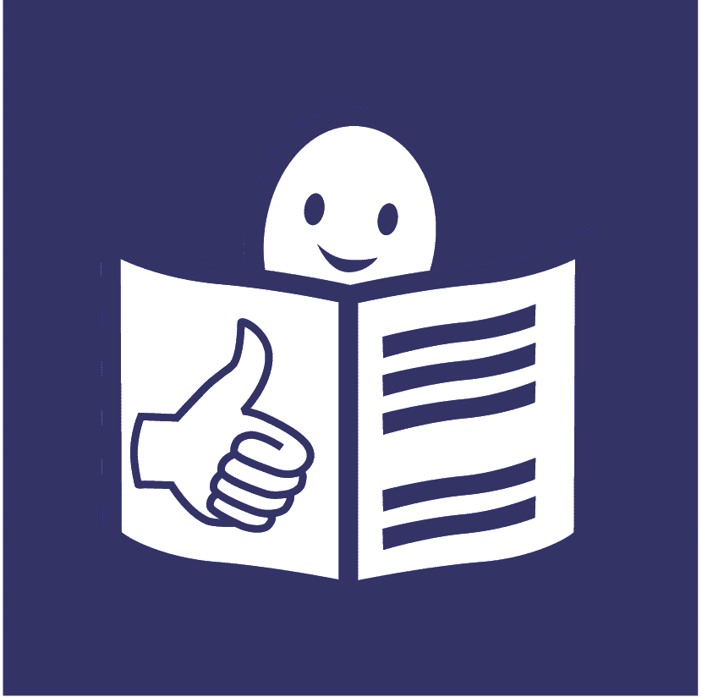

Who we are

We are called Human Rights Watch.

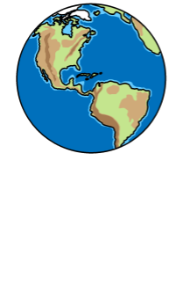

We work to make sure everyone in the world is treated fairly and gets their rights.

What is this report about?

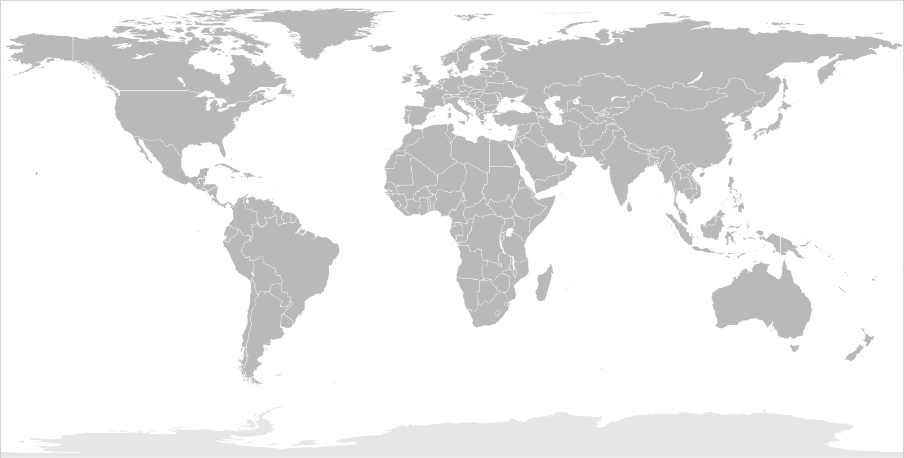
This report is about what is happening to people with disabilities and older people in a country called South Sudan.

South Sudan is in Africa.

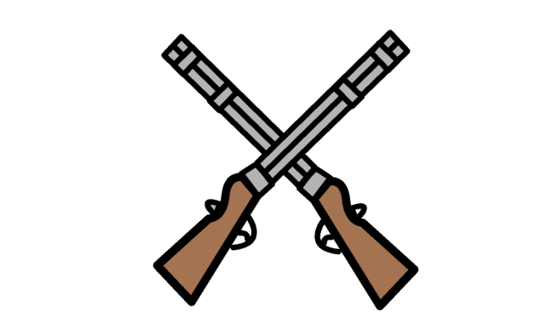

There is a war in South Sudan where two sides are fighting each other.

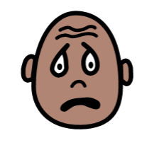
Many people have been hurt or killed in the fighting.

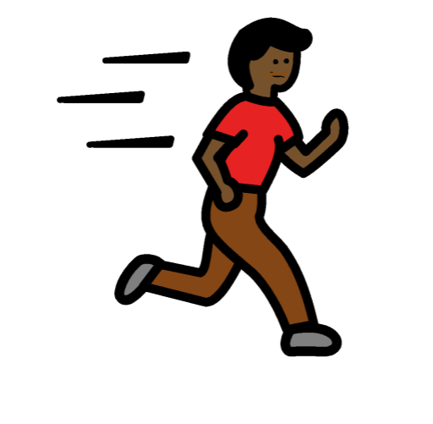

Many people have had to leave their homes very quickly because of the fighting.

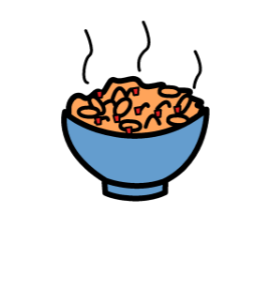

There are also big problems with food in South Sudan at the moment.

Many people do not have enough to eat.

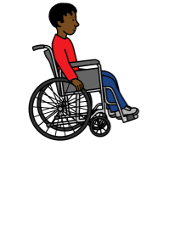
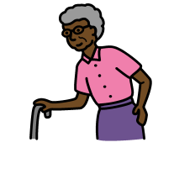

People with disabilities and older people can be in worse danger because of these problems.

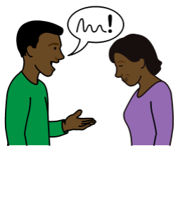

We spoke to people with disabilities, older people and groups that support people in need to find out more.

What are the problems for
people with disabilities and older people?

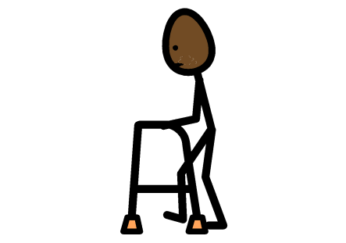
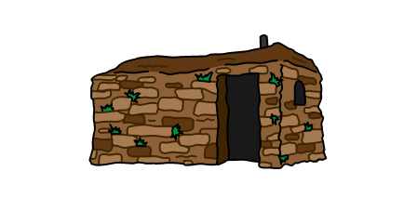
Leaving home if there is danger

It can be harder for people with disabilities and older people to leave quickly if they need to.

It can take them longer to move and get away from danger.

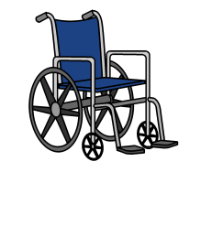

People with disabilities may not have things to help them move, like wheelchairs or walking frames.

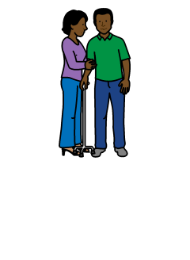

Many people have to ask family or people they know for help.

But it can be hard for people to move or carry them.

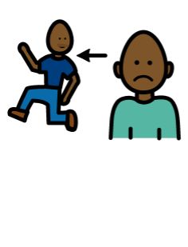
Some families have to leave home very quickly to be safe.

They often have to leave people with disabilities and older people at home if there is danger.

This is because they know that people with disabilities and older people often cannot move as fast as them.

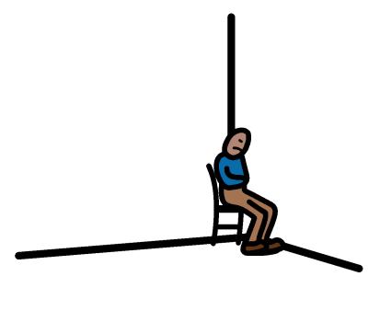
Many people with disabilities and older people are left behind because of this.

They cannot reach safety.

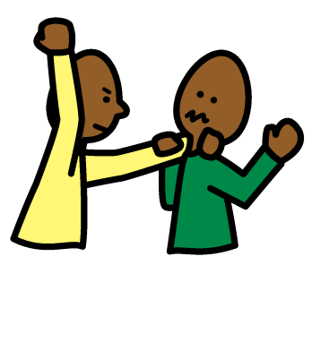

This puts them in danger of being hurt by the people who are fighting.

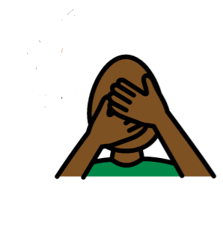

Many people with disabilities and older people have been hurt or killed because of this.
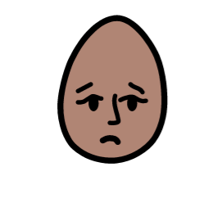
Help for people with disabilities during the fighting

Many people with disabilities and older people find it hard to get the help they need when they have to leave because of fighting.

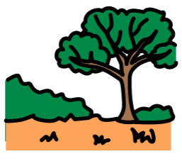

For example, many people had to move to places far away from their homes and towns.

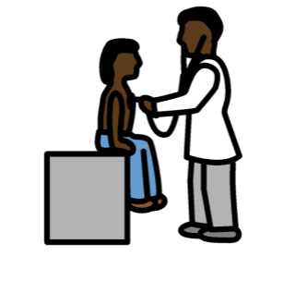

It may be hard for them to get medical help or enough food to eat there.
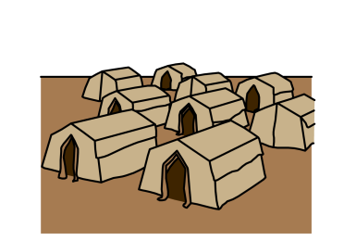

Many people went to live in places called camps.

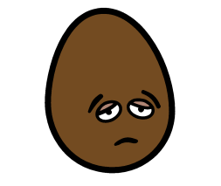
In the camps people can get food, a place to sleep and other basic things they need.

But there are still many problems for people with disabilities and older people.
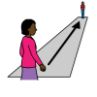
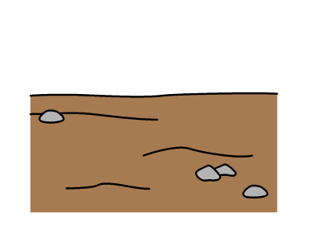
For example, toilets, food and health care can be very far away.

It can also be hard to get to places because of holes in the ground and other problems.

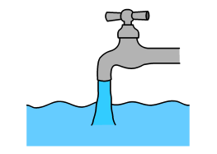

People with disabilities and older people in the camps often find it hard to:

- get to toilets and wash places and use them

- get food

- get to places for medical help

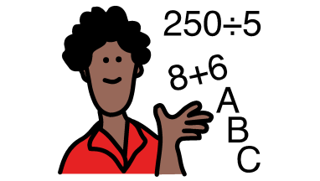

- get a good education

- work and make money

What should happen now?

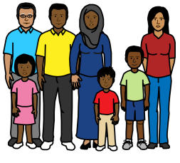

Groups that support people who need help in South Sudan are working very hard.

But we think there should be better support for people with disabilities and older people.

We want the Government of South Sudan to:

- get better information about people with disabilities.
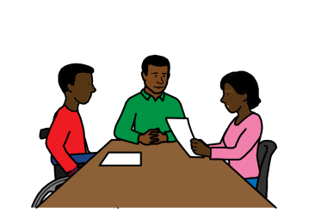
This means finding out who has a disability and what they need.

This will help the Government and other people plan the right support

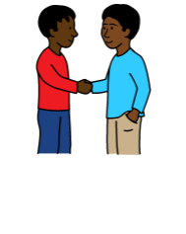

- work with local groups of people with disabilities
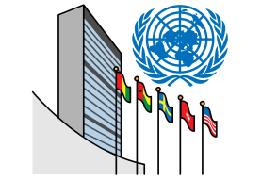
We want the United Nations (UN) and other groups that help people during wars to:

- write and talk about the problems and dangers that people with disabilities and older people face in wars

- have someone to give advice about how best to support people with disabilities and older people

- get good information about what people with disabilities and older people need

- do this by asking people with disabilities and older people what they need

- work to keep people with disabilities and older people safe from being attacked

We want the United Nations (UN) and other groups that help people during wars to:

- make sure people with disabilities can get the support they need in the same way as other people.

They should not be left out or left in danger

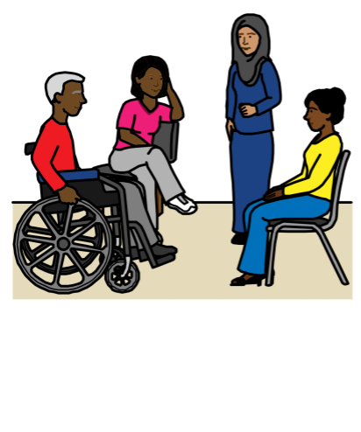

- make sure people with disabilities and older people can have a say in plans that are made

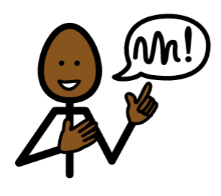

- help set up groups in the camps that speak up for people with disabilities and older people

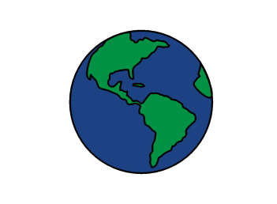
We want countries that give money to help South Sudan to:

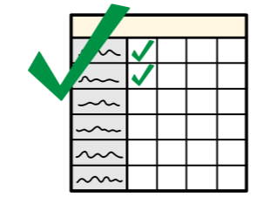

- make sure the groups they give money to also think about people with disabilities and older people

- give money to projects that support people with disabilities and older people

Most pictures by The Picture Communication Symbols ©1981–2016 by Mayer-Johnson LLC a Tobii Dynavox company. All Rights Reserved Worldwide. Thousands of resources available for free at www.boardmakeronline.com

